IOT BASED GARBAGE MONITORING SYSTEM AND NOTIFICATION APPLICATION

**A PROJECT REPORT**

#### Submitted to

**Visvesvaraya Technological University**

#### BELAGAVI - 590 018

#### by

#### DARSHAN D SUTAR 4SU19CS021

#### DEV DUTT GOWDA M J 4SU19CS024 HEGDE VIJAY SURYANARAYANA 4SU19CS033 MATHIN AHAMED 4SU19CS053

##### Under the guidance of

#### Mr. Arjun K

##### Assistant Professor

##### in partial fulfillment of the requirements for the award of the degree of

**Bachelor of Engineering**



**Department of Computer Science & Engineering**

SDM INSTITUTE OF TECHNOLOGY

**UJIRE - 574 240**

**2022-2023**

**SDM INSTITUTE OF TECHNOLOGY**

(Affiliated to Visvesvaraya Technological University, Belagavi)

##### UJIRE – 574 240

#### Department of Computer Science and Engineering

### CERTIFICATE

Certified that the Project Work titled ‘**IOT Based Garbage Monitoring System and Notification Application’** is carried out by **Mr. Darshan D Sutar**, USN: **4SU19CS021, Mr. Dev Dutt Gowda M J**, USN: **4SU19CS024, Mr. Hegde Vijay Suryanarayana**, USN: **4SU19CS033, Mr. Mathin Ahamed**, USN: **4SU19CS053,** bonafide students of SDM Institute of Technology, Ujire, in partial fulfillment for the award of the degree of **Bachelor of Engineering** in Computer Science and Engineering of Visvesvaraya Technological University, Belagavi during the year 2022-2023. It is certified that all the corrections/ suggestions indicated for Internal Assessment have been incorporated in the report deposited in the departmental library. The report has been approved as it satisfies the academic requirements in respect of the project work prescribed for the said Degree.

##### Mr. Arjun K Dr. Thyagaraju G S Dr. Ashok Kumar T

Asst. Professor and Guide Professor and Head Principal

Signature with date and seal:

##### External Viva

##### Name of the Examiners: Signature with Date

1.

2.

**Acknowledgement**

**_**

It is our pleasure to express our heartfelt thanks to Mr. Arjun K, Assistant Professor, Department of Computer Science and Engineering, for his supervision and guidance which enabled us to understand and develop this project.

We are indebted to Dr. Thyagaraju G S, Head of the Department and Dr. Ashok Kumar T, Principal, for their advice and suggestions at various stages of the work. We also extend our heartfelt gratitude to Mr. Pradeep Rao, Project Coordinator for his assistance and the management of SDM Institute of Technology, Ujire, for providing us with a good learning environment, library, and laboratory facilities.

Lastly, we take this opportunity to offer our regards to all of those who have supported us directly or indirectly in the successful completion of this project work.

Darshan D Sutar

Dev Dutt Gowda M J

Hegde Vijay Suryanarayana Mathin Ahamed

**Abstract**

In today's world there is an immense growth in the population of the cities due to this rapid urbanization there is a waste collection that leads to various infectious diseases in the environment. There is a concept with the prototype which we have built that is the Recycle, Reuse, Reduce policies throughout this waste management system. access to get real-time information about each bin and avoid overloading of these bins. The proposed framework reduces the labor cost and saves time and energy of the system. access to get real-time information about each bin and avoid overloading of these bins. access to get real-time information about each bin and avoid overloading of these bins. The proposed framework reduces the labor cost and saves time and energy of the system. The main components we used in making this prototype are Arduino, NODEMCU, Servo Motor and Ultrasonic Sensors. The software component is the application named as Blynk which is used to get notification. This model can be a start to smart dustbin management system in the cities.

# Table of Contents

##### Page No.

##### Abstract i

Table of Contents ii

List of Figures iv

List of Tables v

|  |  |  |
| --- | --- | --- |
| **Chapter 1** | **Introduction** | **1** |
| 1.1 | Project Introduction | 1 |
| 1.2 | Problem Description | 2 |
| **Chapter 2** | **Literature Review** | **3** |
| 2.1 | Literature Survey | 3 |
| 2.2 | Comparative Analysis of the Related Work | 4 |
| 2.3 | Summary | 5 |
| **Chapter 3** | **Problem Formulation** | **6** |
| 3.1 | Problem Statement | 6 |
| 3.2 | Objectives of the Present Study | 6 |
| 3.3 | Summary | 6 |
| **Chapter 4** | **Requirements and Methodology** | **8** |
| 4.1 | Hardware Requirements | 8 |
| 4.2 | Software Requirements | 8 |
| 4.3 | Methodology Used | 9 |
| **Chapter 5** | **System Design** | **10** |
| 5.1 | Architecture of the Proposed System | 10 |
| 5.2 | System Flowchart | 11 |
| **Chapter 6** | **Implementation** | **12** |
| 6.1 | Pseudocode | 12 |
| **Chapter 7** | **System Testing, Results and Discussion** | **14** |
| 7.1 | System Testing | 14 |
| 7.2 | Result Analysis | 14 |
| 7.3 | Summary | 19 |
| **Chapter 8** | **Conclusion and Scope for Future Work** | 20 |

##### 

* 1. Conclusion 20
  2. Scope for Future work 20

##### References Publication Details Personal Profile

# List of Figures

|  |  |  |
| --- | --- | --- |
|  |  | Page No. |
| Figure 5.1 | Architecture of the Proposed System | 10 |
| Figure 5.2 | Flowchart of the Proposed System | 11 |
| Figure 7.1 | Overall architecture of the project | 15 |
| Figure 7.2 | The connectivity of the sensor | 15 |
| Figure 7.3 | The connection Arduino and buzzer | 16 |
| Figure 7.4 | Program and output of respective sensor | 16 |
| Figure 7.5 | ESP32 connected with ultrasonic sensor | 17 |
| Figure 7.6 | Program and output of ESP32 on serial monitor | 17 |
| Figure 7.7 | Real-time display of bin on web dashboard | 18 |
| Figure 7.8 | Monitoring of bin on mobile and alert message | 18 |

# List of Tables

|  |  |  |
| --- | --- | --- |
|  |  | Page No. |
| Table 2.1 | Comparative Analysis | 4 |
| Table 4.1 | Hardware requirements | 8 |
| Table 4.2 | Software requirements | 8 |
| Table 7.1 | Unit test cases | 14 |

# Introduction

## Chapter 1

## Project Introduction

A smart City is a city development that is usually done and helps in managing multiple times the various communication technology. Waste management has been the major issue as well as the task in most of the cities so that they inculcate the best way of waste disposal method. Today in most of the public places there are no proper method is followed, because we cannot monitor the dustbins manually. Introduction of the smart bin and using the sensors to monitor them using embedded systems for real time data processing. This data will have a optimization method to know the various applications such as saving money, saving fuel and importantly less time. One of the main concern with our cities are the waste management which impacts the health and environment of our society. Since it is a customized path for waste management trucks to reduce trips leading to less population and reduction in staff. And automation of this system must be done for all the homes, offices, industries, public and private properties.

Introduction of the smart bin and using the sensors to monitor them using embedded systems for real time data processing. This data will have a optimization method to know the various applications such as saving money, saving fuel and importantly less time. One of the main concerns with our cities are the waste management which impacts the health and environment of our society. Since it is a customized path for waste management trucks to reduce trips leading to less population and reduction in staff. And automation of this system must be done for all the homes, offices, industries, public and private properties.

## Problem Description

Nowadays, there are tons of flats and apartments which have been built in the rapid urbanization area. This is due to high housing demands which have been drastically risen as a result of migration from villages to cities to find work in order to accommodate the growing population. The disposal of solid waste from private houses and the residents of the apartments use a common dustbin.

So, The suggested structure lowers personnel costs while also saving the system time and energy. We mostly utilized Arduino, NODEMCU, Servo Motors, and Ultrasonic Sensors to build this prototype. The software element is the Blynk app, which is utilized to receive notifications. This concept might serve as the foundation for a smart waste disposal system in urban areas.

**Literature Review**

## Chapter 2

## Literature Survey

The authors [1] Neha Shinde and Sayli Bhambre, is to use IOT technology (electronics and application) to improve the present urban waste management situation and enable two-way communication between the infrastructure and the operators/administrators. In the suggested system, there are several trash cans scattered across the city or on the campus. Each trash can has a low-cost embedded device that tracks the level of the trash cans and a distinctive ID that makes it simple to determine which trash can is full.

The authors [2] Sayali Suryakant Chalke and Mohini Bhalero . Information concerning garbage container filling is handled automatically by the system during the creation of an ideal route in order to solve optimization problems. When the garbage cans are close to overflow, a GSM module is utilised to connect with the server room, and an alert will be delivered. The position of the trash cans can be determined with the aid of the GPS module. The coordinate location of the trash container, which will be given by the GPS module, will also be included in the warning signal. This system had a dashboard, an Android app for tracking rubbish, and it also gave the driver the best route for collecting waste.

The authors [3] Prajakta More and Shelkikar R.P have suggested that a new system is required to dispose of trash appropriately. By offering an IOT-based solution, the tracking, gathering, and management processes may be watched over. LoRa technology is one method for ensuring the efficiency and dependability of the system. Compared to Wi- Fi or Bluetooth, LoRa technology is utilised for long-distance data transfer. Here, data from the trash can is collected by sensors and transmitted to the gateway using LoRa Technology. With MQTT, the data from the gateway is gathered and stored in the cloud over the Internet. The functioning of the suggested system design takes into account the initial level of solid waste segregation.

The authors [4],Minhaz Uddin Sohag and Amit Kumer Podder created an IOT-based system that uses garbage bin status to inform the user and the relevant authorities of the level. The identity system, automatic lid system, micro-controller, display system, and communication system are all coordinated by an integrated Arduino programme. On the front side of the trash can is an ultrasonic sensor. The ultrasonic sensor's transmitter

generates an ultrasonic sound that is audible to humans, and the receiver picks up the sound waves that are reflected off of solid things. For the smart waste management system, a prototype of a smart trash can is being created.

The authors [5] Innu Sosunova and Jari Porras Eventually, more cooperation between public and private parties will be necessary to effectively improve trash management. Using GPS technology to map the current garbage collection truck routes and identify the places where the collection is not being done. Newly optimised routes are created based on inputs such as geography, demand from locals, frequency, and traffic conditions. Blockchain technology may be the foundation of SWM systems. Blockchain technology uses public key cryptography systems and cryptographic hash functions to assure the decentralisation and security of transactions. SWM systems that determine the individual cost of waste management frequently employ the pay-as-you-throw usage-pricing model, in which users are paid a fee depending on the amount of garbage they produce.

## Comparative Analysis of the Related Work

The table 2.1 discusses the comparative analysis of the current systems considering the suggested proposal.

|  |  |  |  |
| --- | --- | --- | --- |
| **Sl. No** | **Author(s)** | **Algorithms/Techniques** | **Performance Measures** |
| **1.** | Sayali Suryakant Chalke and Mohini Bhalera | The level of garbage in the bin is detected by using the ultrasonic sensor and communicates to control room using GSM system | Accuracy |
| **2.** | Prajakta More and Shelkikar R.P | Need of new mechanism to properly dispose the waste. | Accuracy |
| **3.** | Neha shinde and Sayli Bhambre | A centralized system for real-time monitoring of the garbage | Accuracy |

**Table 2.1 Comparative Analysis**

## Summary

In today's world there is an immense growth in the population of the cities due to this rapid urbanization there is a waste collection that leads to various infectious diseases in the environment. There is a concept with the prototype which we have built that is the Recycle, Reuse, Reduce policies throughout this waste management system.

Access to get real-time information about each bin and avoid overloading of these bins. The proposed framework reduces the labor cost and saves time and energy of the system. access to get real-time information about each bin and avoid overloading of these bins. The proposed framework reduces the labor cost and saves time and energy of the system.

## Chapter 3

**Problem Formulation**

## Problem Statement

The greatest problem regarding waste management in developing countries begins at the very starting point of the process. Due to lack of proper systems for disposal and collections, wastes and garbage’s end up in the roads and surrounding. According to a report Zurburg 2002, the amount of waste generation in 2010 was around 20,000 tons per day, and it is estimated that by 2025 the amount will be no less than around 47000 tons per day. With the existing methods of collecting and disposal it is near impossible to manage such amount of waste in the future as around 30% of waste end up on the roads and public places due to ineffective disposing and collecting methods. Not only that, there is even no systematic methodology for the collected garbage for treating and recycling thus most of them end up in landfilling and river water, making the environment unhealthier. The prime impediment of implementing smart waste management system based on IoT in a developing country is the social and economic infrastructure of the country itself. The initial stage of this system comprises of proper disposal and collection, which is the biggest challenge. In addition, to motivate and influence people to follow proper waste disposal methods is also important

## Objectives of the Present Study

The objectives of the proposed project are as follows:

* + - Study and Comparative analysis of waste Management.
    - Designing and Modelling of efficient system for the monitoring of smart bins.
    - To bring a suitable model so that it can be installed and managed easily and efficiently.

## Summary

In today's world there is an immense growth in the population of the cities due to this rapid urbanization there is a waste collection that leads to various infectious diseases in the environment. There is a concept with the prototype which we have built that is the Recycle, Reuse, Reduce policies throughout this waste management system.

Access to get real-time information about each bin and avoid overloading of these bins. The proposed framework reduces the labor cost and saves time and energy of the system. access to get real-time information about each bin and avoid overloading of these bins. access to get Realtime information about each bin and avoid overloading of these bins. The proposed framework reduces the labor cost and saves time and energy for the system.

## Chapter 4

**Requirements and Methodology**

## Hardware Requirements

The hardware requirements for the proposed project are depicted in Table 4.1.

|  |  |  |
| --- | --- | --- |
| **Sl. No** | **Hardware/Equipment** | **Specification** |
| 1. | Arduino Uno | Microcontroller based on ATmega328P |
| 2. | Buzzer | KY-006 |
| 3. | Ultra-Sonic Sensor | 2cm - 400cm noncontact measurement |
| 4. | Alcohol Sensor | MQ-3 Sensor |
| 5. | Smoke Sensor | MQ-2 Sensor |
| 6. | GPS module | NEO-6M GPS module, 2.5m horizontal position accuracy |
| 7. | ESP32 | Micro-processor with Wi-Fi |

**Table 4.1: Hardware requirements**

## Software Requirements

The software requirements for the proposed project are depicted in Table 4.2.

|  |  |  |
| --- | --- | --- |
| **Sl. No** | **Software** | **Specification** |
| 1. | Windows OS | 64 bit |
| 2. | Arduino IDE | 64 bit |
| 3. | Blynk | 2.0 |

**Table 4.2: Software requirements**

## Methodology Used

The proposed stroke prediction system is implemented using the following steps:

1. **Connection of sensor:** The first step is to connect the sensor to the microcontroller, here we are using two microcontrollers, one is the Arduino Uno, and another is ESP32.
2. **Data processing:** The next step is to process the code to microcontroller to get the data from respective sensor, here we will be collecting data mainly from ultrasonic sensor.
3. **Sending data to Cloud:** After we get data from ultrasonic sensors, we store the data in the cloud, here we are using the Blynk cloud as it is easy to store data and we can develop our application on this cloud and can monitor real time data so it can be easily displayed to the user with friendly interface.
4. **Sending alert message through WhatsApp:** Here we will be using WhatsApp to send alert messages to the user, this is done using the Wi-Fi feature present in the ESP32 module, once the bin is full the user will get a message as the dustbin is full.
5. **Google maps for Tracking the bin:** By using the neo-6m GPS module and ESP32 will be display the location of the bins which are full so that it can be tracked by the municipal drivers.

## Chapter 5

**System Design**

## 5.1 Architecture of the Proposed System

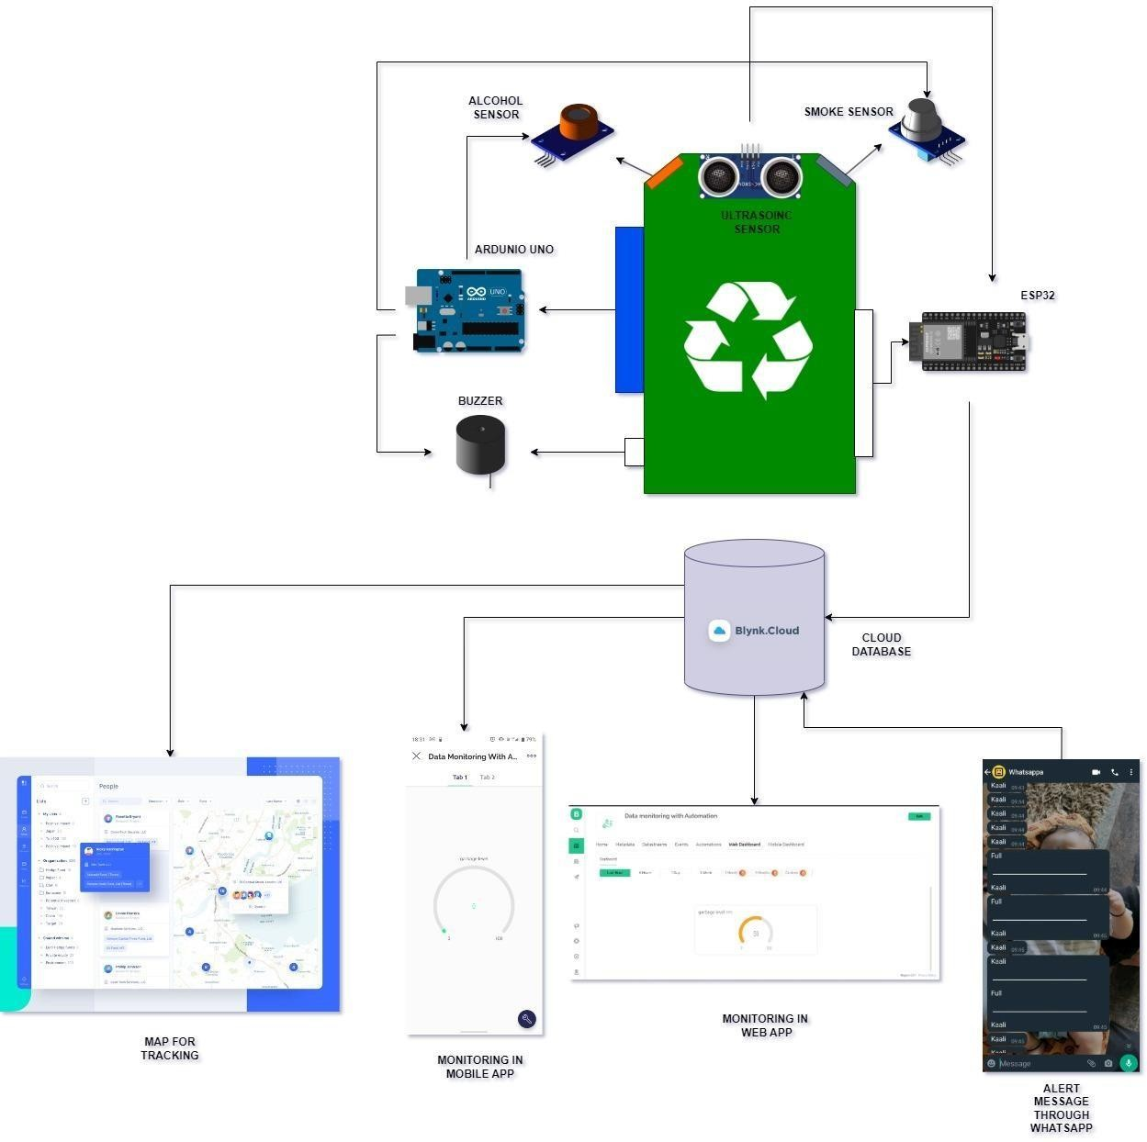

**Figure 5.1: Architecture of the proposed system**

The above diagram shows that the Arduino uno board is connected to the alcohol and smoke sensor and a buzzer, such that if it detects the alcohol or smoke the buzzer will get activated and will give signal, there is another module known as ESP32 which is connected to ultrasonic sensor whose data is send to Blynk cloud through which we can

monitor the real-time data in web application and mobile application, it contains WhatsApp bot that is used to send alert messages to the user and there is implementation of map to track the bins which are full.

## System Flowchart

A system flowchart is a way of depicting how data flows in a system and how decisions are made to control events. Figure 5.2 depicts the system flowchart.

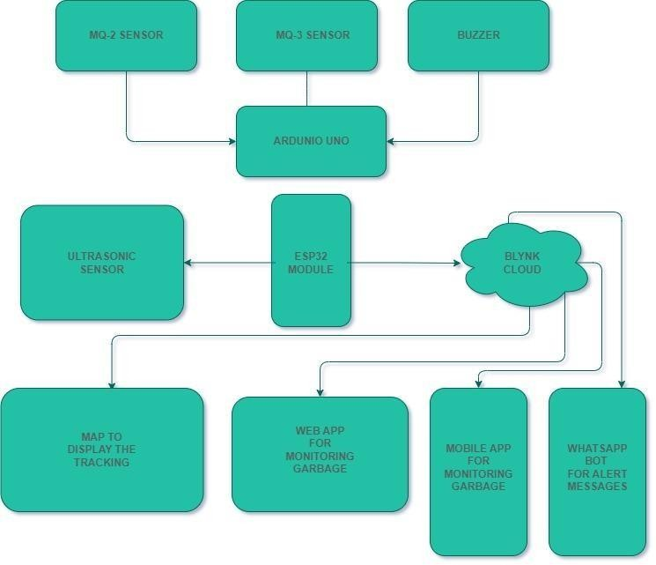

**Figure 5.2: System Flowchart**

The readings from the MQ2 and MQ3 sensor is collected using Arduino. Ultrasonic sensor is connected to esp32 module which send data to blynk cloud using this cloud the web application is built for monitoring system and a messaging module is build.

## Chapter 6

**Implementation**

## 6.1 Pseudo code

// Function for monitoring the bin level.

void binlevel()

{

digitalWrite(trig, LOW); delayMicroseconds(2); digitalWrite(trig, HIGH); delayMicroseconds(10); digitalWrite(trig, LOW);

long t = pulseIn(echo, HIGH); long cm = t / 29 / 2; if(cm<depth){

Serial.println("full"); sendMessage("full");

}else{

Serial.println("Empty"); sendMessage("Empty");

}

Serial.println(cm); long level= depth-cm; if (level<0)

level=0;

level = map(level,0,depth-3,0,100); Blynk.virtualWrite(V0, level);

}

// Function for sending messages. void sendMessage(String message){

// Data to send with HTTP POST

String url = "[http://api.callmebot.com/whatsapp.php?phone=](http://api.callmebot.com/whatsapp.php?phone)" + phoneNumber + "&apikey=" + apiKey + "&text=" + urlEncode(message);

WiFiClient client; HTTPClient http; http.begin(client, url);

// Specify content-type header

http.addHeader("Content-Type", "application/x-www-form-urlencoded");

// Send HTTP POST request

int httpResponseCode = http.POST(url); if (httpResponseCode == 200){

Serial.print("Message sent successfully");

}

else{

Serial.println("Error sending the message"); Serial.print("HTTP response code: "); Serial.println(httpResponseCode);

}

http.end();

}

## Chapter 7

**System Testing, Results and Discussion**

## System Testing

|  |  |  |  |  |  |
| --- | --- | --- | --- | --- | --- |
| **Test case number** | **Input** | **Stage** | **Expected behavior** | **Observed behavior** | **Status P=Pass F=Fail** |
| 1 | Working of Alcohol and Smoke sensor | Detection using sanitizer and smoke | If detected, the buzzer will get activated | As expected | P |
| 2 | Working of ultrasonic sensor | Real-time monitoring in Blynk cloud | The real-time Monitoring will be shown in web app and mobile  app | As expected | P |
| 3 | Sending of alert message through WhatsApp | Using WhatsApp Bot | If the bin is full, message will be send to the app | As expected | P |
| 4 | Tracking of bin which are full using google maps | Using web Sever and GPS  module | If the dustbin is full, it will be located on the map | As expected | P |

**Table 7.1: Unit test cases**

Table 7.1 shows results of the test conducted using the proposed model. As we conducted several test and our model is responding properly according to the required output.

The first test case was detection of alcohol and smoke sensor using the MQ-2 and MQ-3 sensor so we used sanitizer for detection of alcohol and smoke for detection of smoke.

The second test case was testing of ultrasonic sensor connected to blynk app which can is used to fetch data from ultrasonic sensor and then display on the web and mobile application. The third test case is sending and alert message to WhatsApp bot that once the dustbin is full

it will send message as “full” and once the dustbin is empty it will send the message as “Empty”.

The fourth test case is location tracking, once the dustbin gets full the location is located in the google maps and it will be notified to the user about the location.

## Result Analysis

Figure 7.1 shows the overall assembly of the garbage monitoring system where all the sensor and microcontroller board are assembled in a systematic manner.

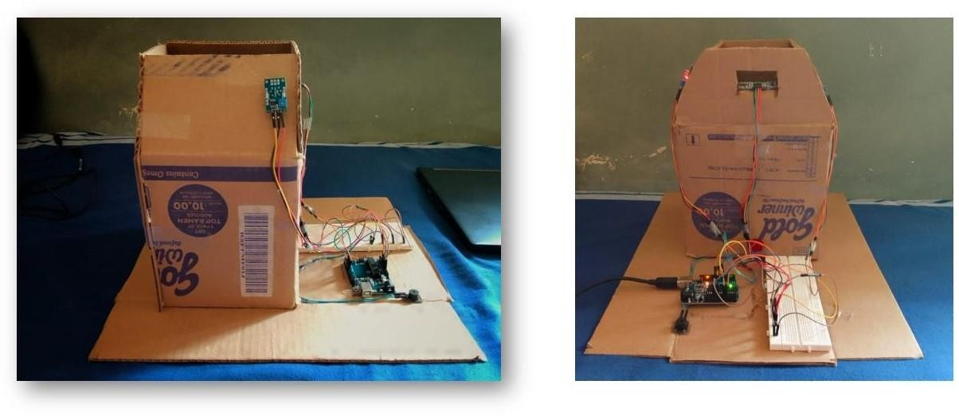

**Figure 7.1: Overall architecture of the project**

Figure 7.2 shows the sensor connected to the bin it contains the ultrasonic sensor, smoke sensor and alcohol sensor.

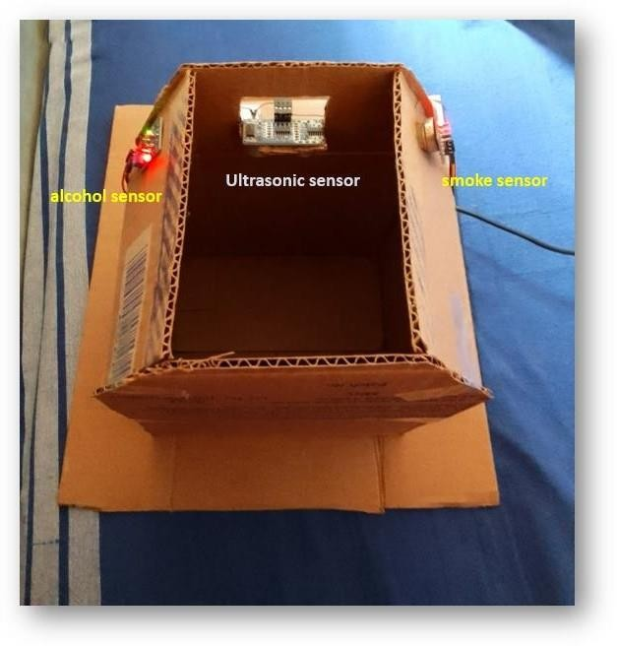

**Figure 7.2: The connectivity of the sensor**

Figure 7.3 shows the connectivity of the Arduino uno microcontroller and the buzzer which response\ based on the connectivity of smoke and alcohol sensor.

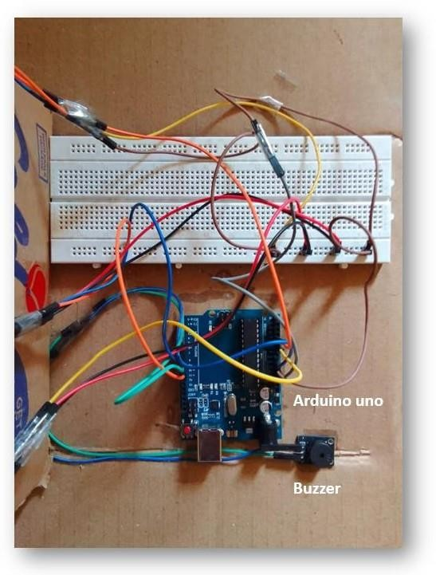

**Figure 7.3: The connection of Arduino uno and the buzzer**

Figure 7.4 shows the values of the ultrasonic sensor, smoke sensor and alcohol sensor on the serial monitor.

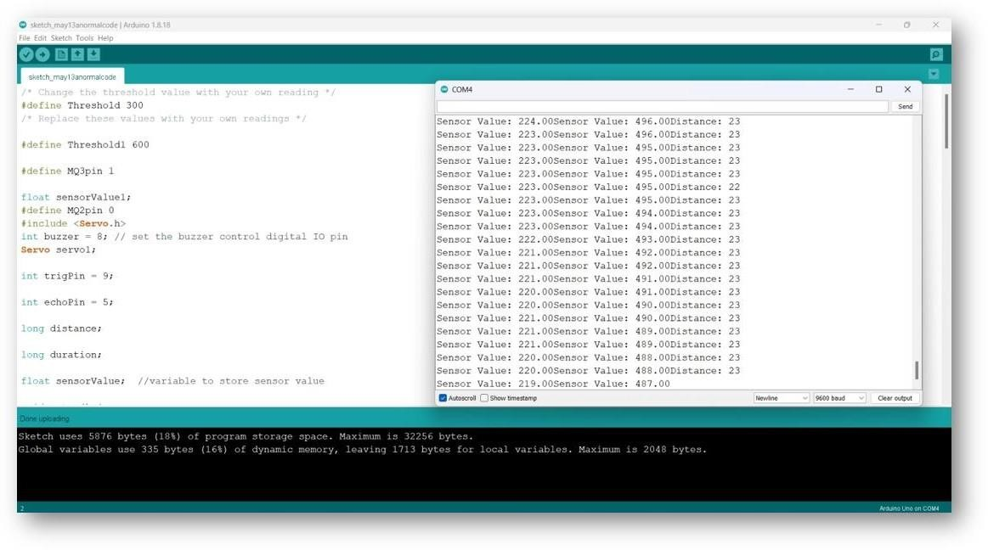

**Figure 7.4: program and output of the respective sensor on serial monitor**

Figure 7.5 shows the connectivity between the ESP32 module and the ultrasonic sensor.

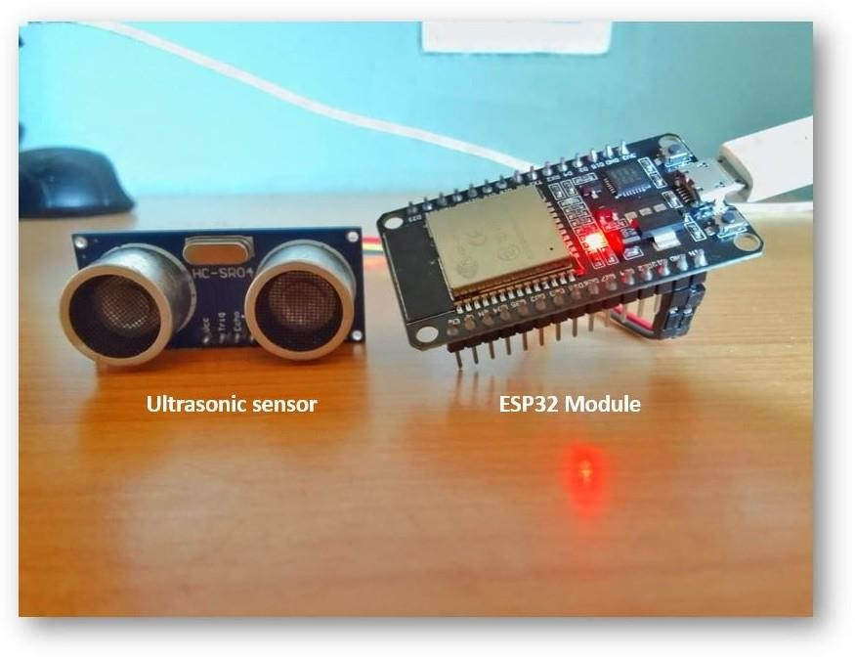

**Figure 7.5: ESP32 connected with ultrasonic sensor.**

Figure 7.6 shows the output of ESP32 module and the connectivity of module to the Blynk cloud and WhatsApp bot on serial monitor.

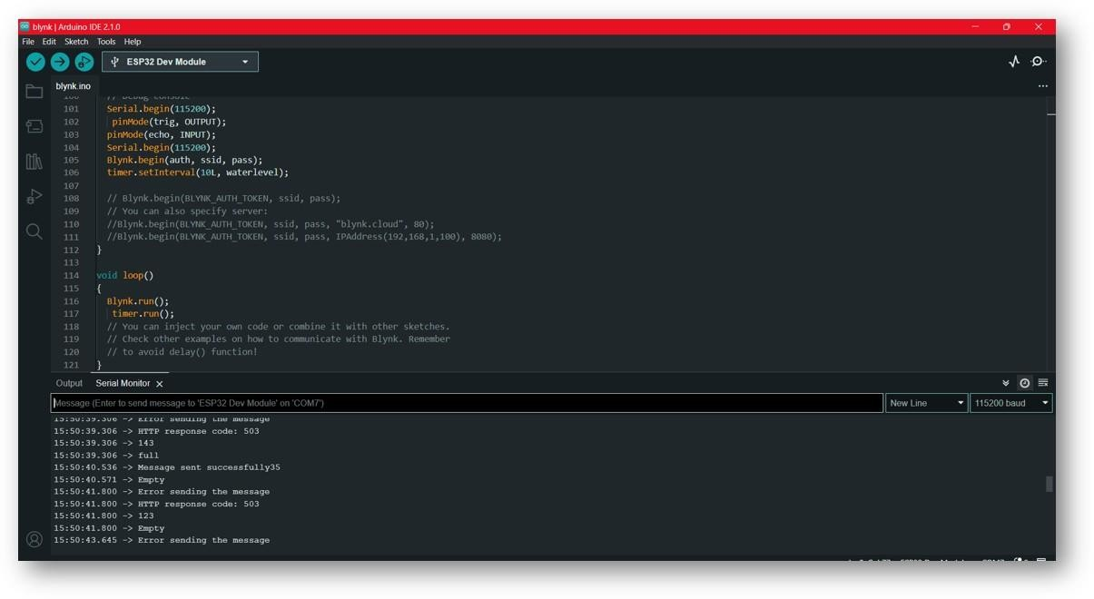

**Figure 7.6: Program and output of ESP32 on serial monitor**

Figure 7.7 is the website dashboard where the real-time monitoring of the bin is displayed.

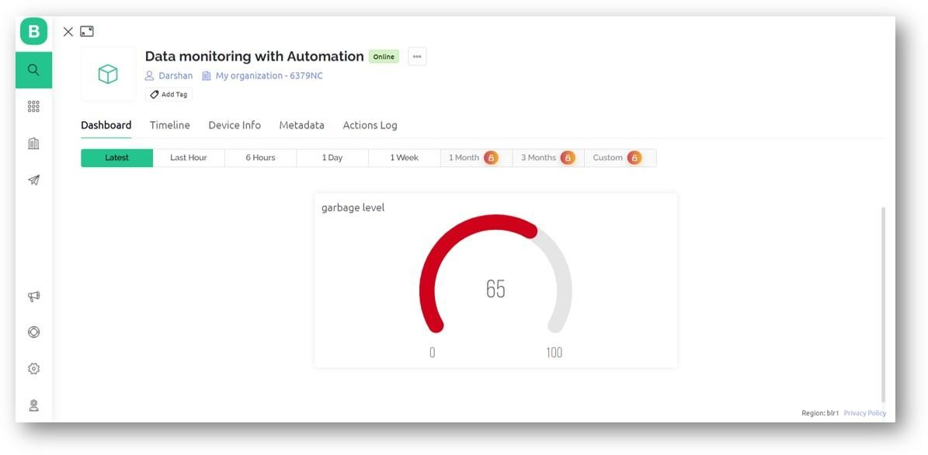

**Figure 7.7: Real-time display of bin on web dashboard**

Figure 7.8 shows the monitoring of bin in mobile application and sending of alert message to WhatsApp whether the bin is full or empty.

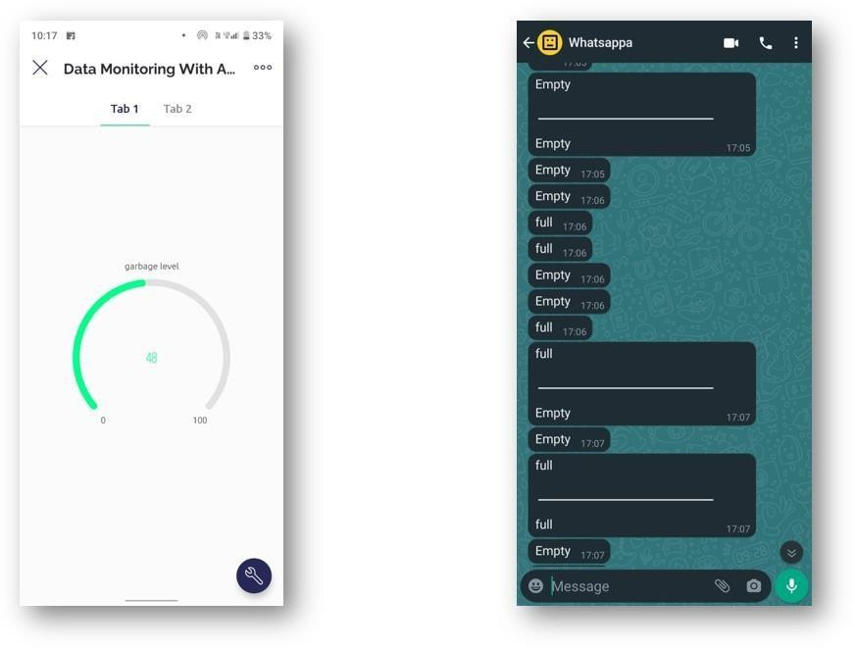

**Figure 7.8: Monitoring of bin on mobile application and alert message in WhatsApp**

The above snapshot gives the front view and top view of the overall of garbage monitoring system where we can see the model and the circuitry of the entire system.

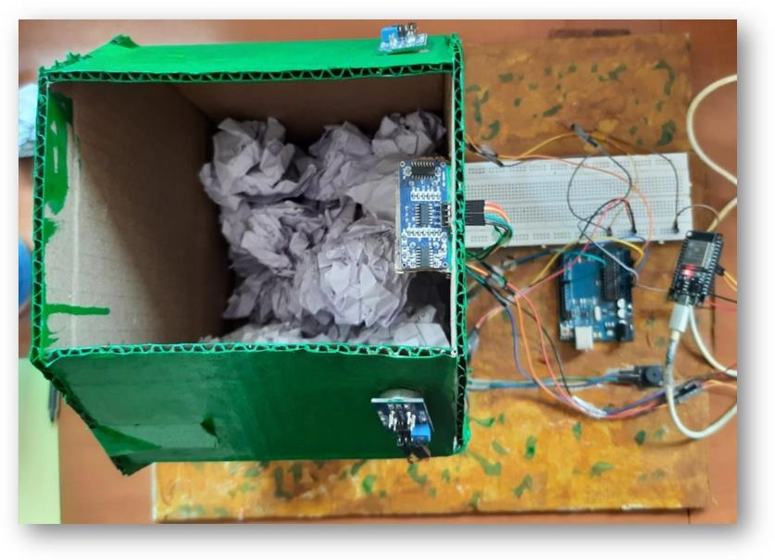

The above snapshot gives the overall top view of the garbage monitoring system

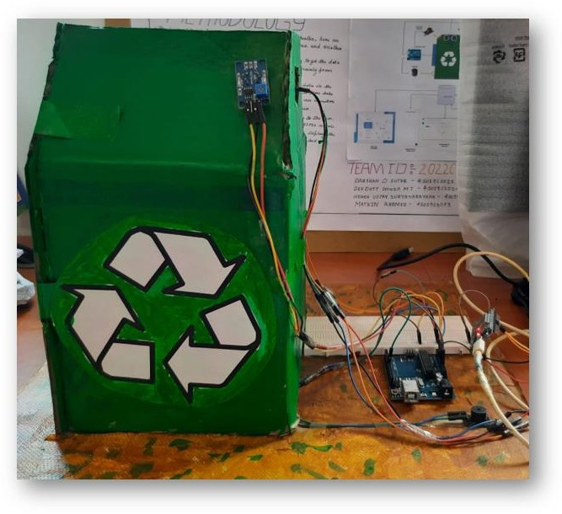

The above snapshot gives the overall side view of the garbage monitoring system

## Summary

The application was developed using the Arduino Uno and ESP32 module. The programming languages that were used are embedded C, Blynk cloud, Blynk Mobile application and google maps API, the above figure shows the working of the application at various stages, since Arduino and ESp32 module which provides Wi-Fi and Internet connectivity feature are easy and convenient to use the project is implemented using these two microcontrollers.

## Chapter 8

**Conclusion and Scope for Future Work**

## Conclusion

Today most of the cities need an effective way to segregate the waste as possible so that the cleanliness is maintained throughout their surrounding bins. The two main factors contributing to pollution are the rapid growth of the population and the expansion of industry. Extreme health risks for the community are posed by trash left in the streets and overflowing dustbins. These issues can be solved by utilizing technological advancement. A bin notifies the collecting truck for cleaning when it exceeds its threshold limit, saving time, money, and energy. The Arduino is convenient since it prevents bin overflow. It is helpful for IoT-based smart cities, which serve to maintain a healthy environment for both society and the populace. This initiative was started to support the idea of smart cities and create a clean India.

## Scope for Future Work

Future system upgrades may include several sensors, if they were practical at the time. As technology progresses, additional sensors might also be added to the system to satisfy demands. It is possible to create smart phone applications that are easier to use, more effective, and more user-friendly. Future system upgrades may include several sensors if they were practical at the time. As technology progresses, additional sensors might also be added to the system to satisfy demands. It is possible to create smart phone applications that are easier to use, more effective, and more user-friendly.

**References**

1. Neha shinde, Sayli Bhambre, Shraddha Thakur, Varsha Devkule "A Survey on Garbage Collection and Monitoring System for Smart cities using IOT", ISSN 2395- 0072, Volume: 05 Issue: 02, IRJET, Feb-2018.
2. Sayali Suryakant Chalke, Mohini Bhalerao, Swapnali Bangar, Dhanashree Gaikwad,

S. G. Dhengre "A Survey on IOT Based Smart Garbage Monitoring System", ISSN 2454-132X, Volume:04, Issue 02, IJARIIT.

1. Prajakta More, Shelkikar R.P "A Survey on Garbage Monitoring using IOT",ISSN 2319-8753,Vol. 8, Issue 6, June 2019.
2. Minhaz Uddin Sohag, Amit Kumer Podder "Smart garbage management system for a sustainable urban life”, Volume 11,September 2020
3. Innu Sosunova, Jari Porras"IoT-Enabled Smart Waste Management Systems for Smart Cities: A Systematic Review", IEEE, July -2022
4. Harshita Chugh, Dushyant singh, Shahensha shaik, Ashwani Singla "IOT Based Smart Bin",e-ISSN: 2395-0056,Volume: 04 Issue: 09,Sep -2019
5. Murugaanandam S, Ganapathy V and Balaji R, "Efficient IOT Based Smart Bin for Clean Environment",Research Gate,April 2018
6. Dr.N.Sathish Kumar, B.Vijayalaxmi, R. Jeniferprarthana, A .Shankar "IOT Based Smart Garbage alert system using Arduino UNO",IEEE,July-2019
7. Mohammadhossein Ghahramani, MengChu Zhou ,Anna Molter, and Francesco Pilla"IoT-Based Route Recommendation for an Intelligent Waste Management System",IEEE INTERNET OF THINGS JOURNAL, VOL. 9, NO. 14,

JULY 15, 2022

1. B Chowdhury and M U Chowdhury, “RFID based real-time smart waste management system in telecommunication network and applications conference 2007.ATNAC 2007.Australasian. IEEE, 2007

**Publication Details**

The paper has been send to publishing for “International Journal of Engineering applied science and technology” is reviewed and accepted with ISSN: 2455-2143 DOI: 10.33564.

**Personal Profile**

|  |  |
| --- | --- |
| **Mr. Arjun K,** Asst. Prof. Project Guide  Darshan | **Mr. Arjun K** received his B.E. degree in Computer Science and Engineering from MITK Kundapura Engineering College in year 2010, and M.Tech. degree in Computer Science from VTU PG center Belagavi in 2012.  His area of interest includes Java, C, programming, IoT, Computer Graphics.  Mr. Arjun K is a life member of Indian Society for Technical Education (ISTE).  **Email ID:** [arjunk@sdmit.in](mailto:arjunk@sdmit.in)  **Contact No**: 9449406858  Name: Darshan D Sutar USN: 4SU19CS021  Address:#15/3 Vinayaka Nilaya, Bengaluru E-mail ID: [darshansutar2001@gmail.com](mailto:darshansutar2001@gmail.com) Contact Phone No: 8618844144 |
| Devdutt | Name: Dev Dutt Gowda M J USN: 4SU19CS024  Address:Manimakki ,kelagur Post, Chikkamagaluru E-mail [ID:devduttgowda@gmail.com](mailto:devduttgowda@gmail.com)  Contact Phone No: 9632795167 |

|  |  |
| --- | --- |
| Vijay | Name: Hegde Vijay Suryanarayana USN: 4SU19CS033  Address:110/A Shirnal Post, Yellapura E-mail ID: [hegdevijay8@gmail.com](mailto:hegdevijay8@gmail.com) Contact Phone No: 7349137874 |

|  |  |
| --- | --- |
| Mathin | Name: Mathin Ahamed USN: 4SU19CS053  Address: Ganesh Colony ,New Town, Bhadravathi E-mail ID: [mathinahamed000786@gmail.com](mailto:mathinahamed000786@gmail.com) Contact Phone No: 9353833310 |